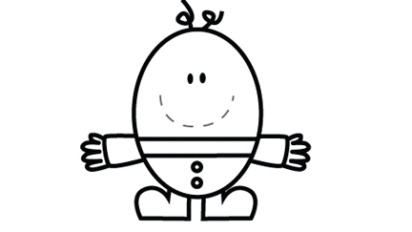
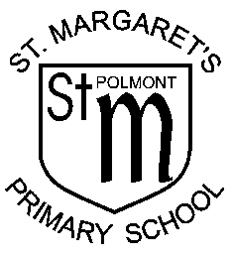
Stage 1
Humpty Dumpty Word Wall

Week beginning | My Words
 | a | at | the
 | I | in | it
 | an | is | and
 | Consolidation
Helpful Hints:
Please help your child to read and write these words. Point to a word and ask your child to read the word. Try to mix the order to make a game with your child. Then ask your child to write the word and compare their answer with the table above. Please sign the words when you are confident that your child, if asked, could read and write the word.
Stage 1
Humpty Dumpty Word Wall

Week beginning | My Words
 | am | me | my
 | did | as | he
 | can | we | into
 | Consolidation
Helpful Hints:
Please help your child to read and write these words. Point to a word and ask your child to read the word. Try to mix the order to make a game with your child. Then ask your child to write the word and compare their answer with the table above. Please sign the words when you are confident that your child, if asked, could read and write the word.

Stage 1
Humpty Dumpty Word Wall

Week beginning | My Words
 | go | got | get
 | if | for | on
 | be | but | you
 | Consolidation
Helpful Hints:
Please help your child to read and write these words. Point to a word and ask your child to read the word. Try to mix the order to make a game with your child. Then ask your child to write the word and compare their answer with the table above. Please sign the words when you are confident that your child, if asked, could read and write the word.

Stage 1
Humpty Dumpty Word Wall

Week beginning | My Words
 | was | went | his
 | have | just | to
 | Consolidation
 | your | by | only
Helpful Hints:
Please help your child to read and write these words. Point to a word and ask your child to read the word. Try to mix the order to make a game with your child. Then ask your child to write the word and compare their answer with the table above. Please sign the words when you are confident that your child, if asked, could read and write the word.

Stage 1
Humpty Dumpty Word Wall

Week beginning | My Words
 | are | dad | not
 | Consolidation
 | Consolidation and assessment
 | she | come | from
Helpful Hints:
Please help your child to read and write these words. Point to a word and ask your child to read the word. Try to mix the order to make a game with your child. Then ask your child to write the word and compare their answer with the table above. Please sign the words when you are confident that your child, if asked, could read and write the word.

Stage 1
Humpty Dumpty Word Wall

Week beginning | My Words
 | this | that | then
 | with | us | so
 | much | of | our
 | Consolidation
Helpful Hints:
Please help your child to read and write these words. Point to a word and ask your child to read the word. Try to mix the order to make a game with your child. Then ask your child to write the word and compare their answer with the table above. Please sign the words when you are confident that your child, if asked, could read and write the word.

Stage 1
Humpty Dumpty Word Wall

Week beginning | My Words
 | old | do | going
 | out | now | new
 | one | first | little
 | Consolidation
Helpful Hints:
Please help your child to read and write these words. Point to a word and ask your child to read the word. Try to mix the order to make a game with your child. Then ask your child to write the word and compare their answer with the table above. Please sign the words when you are confident that your child, if asked, could read and write the word.

Stage 1
Humpty Dumpty Word Wall

Week beginning | My Words
 | had | see | has
 | play | no | look
 | make | like | made
 | Consolidation and assessment
Helpful Hints:
Please help your child to read and write these words. Point to a word and ask your child to read the word. Try to mix the order to make a game with your child. Then ask your child to write the word and compare their answer with the table above. Please sign the words when you are confident that your child, if asked, could read and write the word.

Stage 1
Humpty Dumpty Word Wall

Week beginning | My Words
 | Consolidation
 | Consolidation and assessment
 | said | big | could
 | our | down | off
Helpful Hints:
Please help your child to read and write these words. Point to a word and ask your child to read the word. Try to mix the order to make a game with your child. Then ask your child to write the word and compare their answer with the table above. Please sign the words when you are confident that your child, if asked, could read and write the word.

Stage 1
Humpty Dumpty Word Wall

Week beginning | My Words
 | him | all | came
 | here | her | before
 | Consolidation
 | Consolidation and assessment
Helpful Hints:
Please help your child to read and write these words. Point to a word and ask your child to read the word. Try to mix the order to make a game with your child. Then ask your child to write the word and compare their answer with the table above. Please sign the words when you are confident that your child, if asked, could read and write the word.

